FORMS FOR DIOCESAN ADVISORS

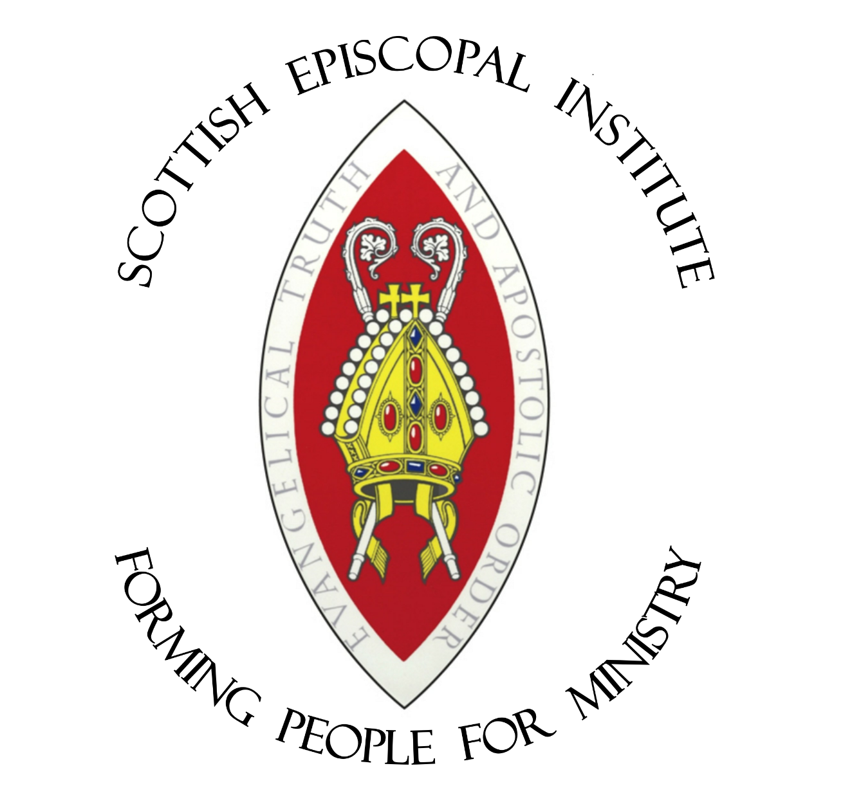

2016-17

Annual timeline

June 2016
Details of Student–Diocesan Advisor pairing sent out.

July/August 2016
Meet student and discuss learning needs.
Note that the first week of July is the cut-off point for registration of students for upcoming September entry following last scheduled BAP.

September 2016
Induction Day. Final programme of study.
Inaugurate regular meetings with students. Discuss Record of Development with student. Students begin IME seminars and (if applicable) course from another academic provider.
Note which residential weekend your student is responsible for worship.

October 2016
First RWE. Students begin residential programme and Bishop’s Reflection Group.

November 2016
Discuss placement with student, and make arrangements with student and Field Education Tutor.

December 2016
Second RWE
18.12.16 first assignment of the year due back to students.

January 2017
Discuss Record of Development. Set date for Appraisal Conference. Third RWE.

January – May 2017
Student (generally) undertakes placement.
Arrange meetings with Placement Supervisor at beginning and end (and, if desired, mid-point) of placement.

March 2017
Discuss Record of Development with student. Review material for Appraisal portfolio (final-year students) and write End-of-Year report. Fourth RWE.

April 2017
Final Year students’ Appraisal Conferences

May 2017
Discuss Record of Development with student. Review material for Appraisal portfolio (continuing students) and write End-of-Year report.
Fifth RWE.

June 2017
Continuing students’ Appraisal Conferences.

July 2017
Summer School. SEI academic year ends.

August 2017
Durham University Assessment Panel meets to approve student progression and confer awards.

Programme of Study Summary

Programme of Study in Initial Ministerial Education

Name of Candidate:

Year of Formation:
Name of Diocesan Advisor/ URC Director of Studies:
Ministry concerned:

Ministerial Pathway:

SEI Studies: Modules, Levels and Submission Dates

Studies at an External Provider:

Dates for review of progress: (it is good to schedule dates for at least the first term’s meetings here)

Date for annual appraisal: (given in January)

Guidance Notes on the Programme of Study (Summary)
(Please note that a different template is used for URC students. Please speak to the URC Director of Studies for more details.)

The Programme of Study contains two documents: the Summary and the Record of Development. These documents may contain material of a confidential nature and come under the Data Protection Act 1998. The Advisor should keep the documents and any other confidential material in locked storage. Access is restricted to the student and the student’s Bishop or URC supervising body. The Principal is entitled to access for monitoring purposes. All other access is only with permission of the student and Advisor. Upon completion of studies, personal records should be destroyed after five years (though a note of assignment assessment results may be kept).

At the beginning of each academic year, the Diocesan Advisor/URC Director of Studies completes a Programme of Study (Summary) with the candidate. The Summary provides an outline of the ministry for which the candidate is being prepared, the stage of formation, and the studies to be taken to meet the formation requirements.

- Name of Candidate
- Year of Formation
- Name of Diocesan Advisor/ URC Director of Studies
- Ministry Concerned – Note whether stipendiary/ NSM; ordinand, Vocational Deacon, Lay Reader.
- Ministerial Pathway – Note the course the student is embarked upon and the overall length of studies. Please note here any previous studies successfully completed by the candidate.
- SEI Studies – Note the studies being done in the coming year and the Level at which they are being studied. Add submission dates if deemed helpful.
- Studies at an external provider – Provide the name of the external provider, the course being done, the subject areas to be studied, and duration of course.
- Dates for review of progress – Detail here how often the Diocesan Advisor or URC Director of Studies and candidate agree to meet to review progress, ensure a Record of Development is kept, and appraisal procedures are met. A monthly meeting is advisable.
- Date for annual appraisal – a date should be set in January with the Chair of the Conference. Adequate information on the student’s progress and an End-of-Year report must be available. It is probable that some marks will not have been received at this point in the year.

Programme of Study (Record of Development)

- Personal Circumstances:
- SEI Studies:

- External Theological Studies:

- Spiritual Development:

- Vocational development:

- Relating to Others:

- Learning and Worship:

- Time Management, Church and Community:

- Candidate/ Advisor Relationship:

- Reflections on Ministry:

Guidance on keeping a Programme of Study (Record of Development)

The Record of Development (i) details the areas of learning that SEI considers essential for formation; (ii) monitors these over the course of the academic year and (iii) furnishes the portfolio used by the Diocesan Advisor/URC Director of Studies to draw up an End-of-Year report for the student’s Appraisal Conference. The notes provide guidelines for maintaining such a Record.

- Personal Circumstances. The Diocesan Advisor/URC Director of Studies should have received notes about the student background and vocational discernment. The student must inform their Advisor if there are any changes to their personal circumstances that may affect their training for ministry or the commitment to training. A note is kept here.

- SEI Studies. A note is kept here of involvement in IME modules (if applicable), Residential Weekends, Bishop’s Reflection Group, Placement and Summer School. Progress in assignments should be monitored to ensure that studies are being completed according to schedule and minimum standards in assessment are being met.

- External Theological Studies. The student must inform the Diocesan Advisor/URC Director of Studies of their progress in studies at an external institute.

- Spiritual Development. Candidates are expected to reflect on developments in their spiritual life (what has been helpful, where the blocks are) and are expected to have a spiritual director/soul-friend throughout the duration of their studies. This relationship is confidential, but note here how it is taking place.

- Vocational Development. Candidates are asked to submit a brief (two sides of A4) reflection as the Appraisal Conference draws near in which they reflect on their life and vocation in relation to their studies. This will be appended to the Advisor’s End-of-Year report.

- Relating to Others. At the beginning, middle, and near the end of the academic year the candidate reflects with their Advisor on how they relate to other people. They should point to their strengths and weaknesses when it comes to relating to others and where they feel they need to grow. The Advisor keeps a brief summary of the discussion.

- Learning and Worship. Record the student’s reflection on the experience of learning and worship in SEI and External Studies – what has been positive, negative, challenging, and where they feel they have learned most. Where appropriate, record feedback on the candidate’s involvement in the leading of worship and Bible Studies, and delivery of sermons, at RWEs.

- Time Management, Church and Community. Students should strive to have some sense of balance between family/friends, studies, employment. Note how commitments are managed and if there are any issues to be resolved.

- Candidate and Diocesan Advisor/Director of Studies Relationship. Note how often meetings have taken place and if both parties are content with the relationship.

- Reflections on ministry. Students are urged to reflect with their Advisors on the breadth of traditions within the SEC or URC, and with the varieties of ministry to be encountered in these traditions.
Appraisal Conference process: End-of-Year Report

Name of Student: Year of Report:

Name of Diocesan Advisor/ URC Director of Studies:

Date of Appraisal Conference:

Report

Comment on the following areas (where appropriate):
- Personal circumstances
- Progress in SEI studies
- Progress in external theological studies
- Spiritual development
- Vocational development – the student’s brief reflection should be appended to the report.
- Relating to others
- Learning and worship leading
- Time management, church and community Involvement
- Student and Diocesan Advisor relationship
- Final brief comment on the student’s overall progress and areas for further learning.

Appraisal Conference process – Appraisal Conference report drafted by the Chair of the Conference

Name of Student:

Name of Diocesan Advisor/ URC Director of Studies:

Name of Chair of Appraisal Conference:

Date of Appraisal:

- Summary of Discussion at the Appraisal Conference:

- Statement on student’s progress in formation and studies:

- Statement on suitability for further training or for authorised ministry:

Signature of Chair Signature of Advisor Signature of Student

Date Date Date

Marking and Moderating 2016-17

Module Title | Number | Tutor | Level | Credits | Students
Foundations for Reflective Practice in Context (Short) | TMM1447 | Tomlinson | 4 | 10 | 12
Introduction to the Bible | TMM1031 | Corsar | 4 | 20 | 15
Introduction to Christian Ethics | TMM1167 | Robinson | 4 | 10 | 12
Introduction to Preaching | TMM1347 | MacLaren | 4 | 10 | 18
Introduction to Christian Worship | TMM1537 | Paton | 4 | 10 | 18
Spirituality and Discipleship | TMM1521 | McLuckie | 4 | 20 | 17
Christian Worship: Principles and Practice | TMM2617 | Paton | 5 | 10 | 9
Developing Preaching | TMM2387 | MacLaren | 5 | 10 | 9
Mission Entrepreneurship: Principles | TMM2427 | TBD | 5 | 10 | 15
Topics in Christian Doctrine | TMM2121 | Mason | 5 | 20 | 2
Reflective Practice in Context (Short) | TMM 2527 | Tomlinson | 5 | 10 | 9
Christian Doctrine in Context | TMM3097 | Robertson | 6 | 20 | 5
Modern Thought and Theology | TMM3681 | Jasper | 6 | 20 | 5

Module  Title | Number | Tutor/  Marker | Level/  Credits | Moderator | Assignments  Due | Mark  Due | Moderation  Due
Foundations for Reflective Practice in Context (Short) | TMM1447 | Tomlinson | 4/10 | Hull | 20.05.17 | 31.05.17 | 10.06.17
Introduction to the Bible | TMM1031 | Corsar | 4/20 | McLuckie | 25.02.17 | 08.03.17 | 18.03.17
Introduction to Christian Ethics | TMM1167 | Robinson | 4/10 | Mason | 08.07.17 | 19.07.17 | 29.07.17
Introduction to Preaching | TMM1347 | MacLaren | 4/10 | Robinson | 27.05.17 | 07.06.17 | 17.06.17
Introduction to Christian Worship | TMM1537 | Paton | 4/10 | MacLaren | 08.04.17 | 19.04.17 | 29.04.17
Spirituality and Discipleship | TMM1521 | McLuckie | 4/20 | Paton | 26.11.16 | 07.12.16 | 17.12.16
Christian Worship: Principles and Practice | TMM2617 | Paton | 5/10 | MacLaren | 27.05.17 | 07.06.17 | 17.06.17
Developing  Preaching | TMM2387 | MacLaren | 5/10 | TBD | 08.04.17 | 19.04.17 | 29.04.17
Mission Entrepreneurship Principles | TMM2427 | TBD | 5/10 | Mason | 08.07.17 | 19.07.17 | 29.07.17
Topics in Christian Doctrine | TMM2121 | Mason | 5/20 | Corsar | 25.02.17 | 08.03.17 | 18.03.17
Reflective Practice in Context (Short) | TMM 2527 | Tomlinson | 5/10 | Hull | 20.05.17 | 31.05.17 | 10.06.17
Christian Doctrine in Context | TMM3097 | Robertson | 6/20 | Jasper | TBD | TBD | TBD
Modern Thought and Theology | TMM3681 | Jasper | 6/20 | Robertson | TBD | TBD | TBD

