SCOTTISH EPISCOPAL CHURCH 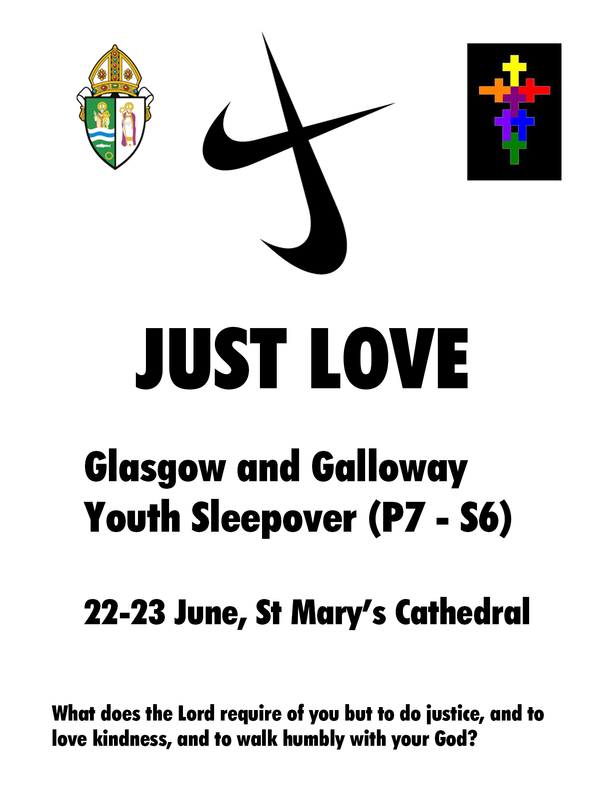
Please arrive at 2.30 pm on Saturday 22 June. The sleepover ends with the main Sunday service at 10.30 am on the Sunday, at which families are very welcome to join us.
Please contact Rev Jim Benton-Evans, Diocesan Youth Chaplain on youth@glasgow.anglican.org or 07702 842727 to register interest.
There is a charge of £5 per participant to cover meals and materials.
Further information overleaf.

SCOTTISH EPISCOPAL CHURCH

JUST LOVE, 22-23 June

This event has been organised by the Diocese of Glasgow and Galloway on behalf of the Provincial Youth Committee. It will be led by a team of Provincial Youth leaders, all of whom are PVG checked. This sleepover event is a social get-together for young people from P7-S6 across the Province and an opportunity to invite friends to join in the fun. We are very grateful to the Provost and Vestry of St Mary’s Cathedral for agreeing to host this event.

The young people have been invited to lead part of the worship on Sunday morning and part of our activity time on Saturday afternoon will be used for devising their own creative worship. There will also be games, activities, a film and discussion around the theme of “Just Love”, exploring how the young people want to see the church speaking out and engaging with the serious justice issues facing our world. This event includes a Saturday evening meal and Sunday breakfast. Please note that after the evening film there will be ‘lights out’ and quiet in the main hall, to allow delegates to get enough sleep.

Address: 300 Great Western Road, Glasgow G4 9JB
How to get there by car: The church is located in the inner West End of Glasgow. Take the M8 to J17 and leave in the direction of Dumbarton. After 160 yards turn right on to Great Western Road: the church is half a mile down the road on the right.

Train/Bus: From Glasgow Queen Street station, take the subway from Buchanan St to St George’s Cross. The church is a short walk from the subway along Great Western Road.

NB Help may be available for transport costs – please contact your diocesan youth representative for details.

Please bring: Sleeping bag, airbed/mat, pillow, towel, toiletries, any necessary medication, pyjamas, change of clothes, a torch. A tin of home baking if possible!

To book a place, please let me know by email: youth@glasgow.anglican.org
Email a scan/photograph of your signed consent form to this address, or post to: Rev Jim Benton-Evans, East End Team Ministry, 1464 Shettleston Road, Glasgow. G32 9AL. Please pay on the day. Consent forms in by 15 June please.

SCOTTISH EPISCOPAL CHURCH

JUST LOVE SLEEPOVER

CONSENT FORM

In order to ensure your child’s safety, we would be grateful if you could complete and return this form.
Please let us know if there are any significant changes. A copy will be retained confidentially by the group leader Rev Jim Benton-Evans (youth@glasgow.anglican.org)

Name of child or young person Church

Diocese Date of Birth

Address of child or young person

Has this young person taken part in a Glenalmond Youth Week? YES NO
Name of person with parental responsibility
Contact email address
Telephone No.
Day |  | Evening

Name of additional contact with parental responsibility (in case of emergency):
Telephone No.
Day |  | Evening

Details of any regular medication, medical condition, mental health issue (eg dietary needs, allergies, asthma, anxiety, epilepsy, diabetes) or disability which leaders should be aware of:

PARENTAL CONSENT
- I give permission for my child, as named above, to take part in this activity
- I understand that while involved in the activities of this group, he/she will be under the control and care of the group leader and/or other adults approved by the church leadership and that, while the staff in charge of the group will take reasonable care of the children, they cannot necessarily be held responsible for any loss, damage or injury suffered by my child during, or as a result of, the activity
In an emergency and/or if I cannot be contacted, I am willing for my child to receive necessary hospital or dental treatment, including an anaesthetic. YES NO
SCOTTISH EPISCOPAL CHURCH
USE OF PHOTOGRAPHIC IMAGES CONSENT FORM
FOR CHILDREN AND YOUNG PEOPLE (UNDER 18)

To comply with General Data Protection Regulation (Regulation (EU) 2016/679) we need your permission before we use any images of your child/children. Please answer the questions below, then sign and date the form.
Name of child

TO BE COMPLETED BY PERSON/ORGANISATION REQUESTING PERMISSION
Location of photograph/video | St Mary’s Episcopal Cathedral, Glasgow
Purpose for taking photograph/video | Promoting youth events in the Scottish Episcopal Church
Media to be used | Photographs/video

TO BE COMPLETED BY PARENT/GUARDIAN OR CARER/OR BY THE YOUNG PERSON (12+)
May we use your child’s image in our promotional publications? | Yes | No
May we use your child’s image on the Scottish Episcopal Church website/social media and its diocesan websites/social media? | Yes | No

Please note that websites/social media can be viewed throughout the world in countries that do not have strict laws relating to the use of personal data or images.

I have read and understand the conditions of use* printed below.

Signature |  | Date

Print Name (in block capitals)

Relationship to the child: Parent/Guardian/Carer (delete as appropriate)

*Conditions of use We will not include details of full names (i.e. first name and surname) of any child in an image on our website/social media or in printed publications without good reason. If we use images in a group they will only be identified with a general label e.g. “children at the Church Fair”. We will not include personal e-mail or postal addresses, or telephone or fax numbers on video, our website/social media or printed publications. We will only use images of young people who are suitably dressed to reduce the risk of such images being used inappropriately.

