## Scottish Episcopal Church

## A Guide to

## The General Synod 2019

## 

## Contents

Preface 1

What is the General Synod? 3

Who are the Members? 3

The General Synod Meeting 5

How to get matters on the Synod Agenda 6

The Rest of the Year 7

Boards and Committees 8

Parking at General Synod 2019 10

General Synod & Scottish Episcopal Institute Officers 11

## Preface

Welcome to this brief introduction guide to the General Synod – the central governing body of the Scottish Episcopal Church. Inside, you will find an outline of the General Synod’s structure and inner workings.

This booklet is not meant to be an official Synod rulebook. You can find that information in the *Code of Canons*, *the Digest of Resolutions* and the Synod’s *Rules of Order*.

The aim of this guide is to lay out some of the thinking behind the organisation and to describe, as simply as possible, how it works.

The General Synod met for the first time on Saturday, 4 December 1982, in St Ninian’s Cathedral, Perth. It replaced a longstanding structure which split church government between two bodies – the Provincial Synod and the Representative Church Council.

Under the old structure, the Provincial Synod dealt with doctrine and discipline while the Representative Church Council concentrated on finance, administration and general Church policy.

In the early 1980s, the Church decided that it needed a much simpler and smaller body to oversee all areas of Church governance. The General Synod was born and brought with it a complete overhaul of Church decision-making and structure.

From its first meeting to the present day, its aim has remained the same – to unite the Church in the life and mission entrusted to us by God.

## What is the General Synod?

The General Synod acts as the Parliament of the Scottish Episcopal Church.

It is the Church’s legislative and deliberative body. Members oversee and direct the work of the Church’s Boards and Committees.

The General Synod meets once a year to vote on two broad types of motion: firstly, on formal changes to Canon Law or internal church policy; secondly on wider issues of national and international concern.

Under the first category, the General Synod could authorise a new baptism service, change the rite for the burial of the dead or change clergy disciplinary procedure.

Subjects covered by the second, broader type of motion have in the past ranged from the situation in the Middle East to nuclear power stations and the loss of rural post offices. In these cases, the General Synod has the power to speak out and call for action on behalf of the whole Church.

The annual meeting also receives reports from its various boards and committees and elects new conveners and members. The Annual Report, which includes the Synod’s accounts, also includes written reports from the Conveners of the Boards and Committees. These reports are normally “taken as read” and are not specifically debated but there is opportunity for questions to be asked of the respective Conveners.

## Who are the members?

The General Synod has 124 elected members – 62 of them clergy and 62 lay people. Each diocese elects a set number of members, according to its size.

In addition, the Church’s seven Bishops, the Conveners of the Provincial Standing Committee and Boards and the Church’s representatives on the Anglican Consultative Council are automatically Synod members.

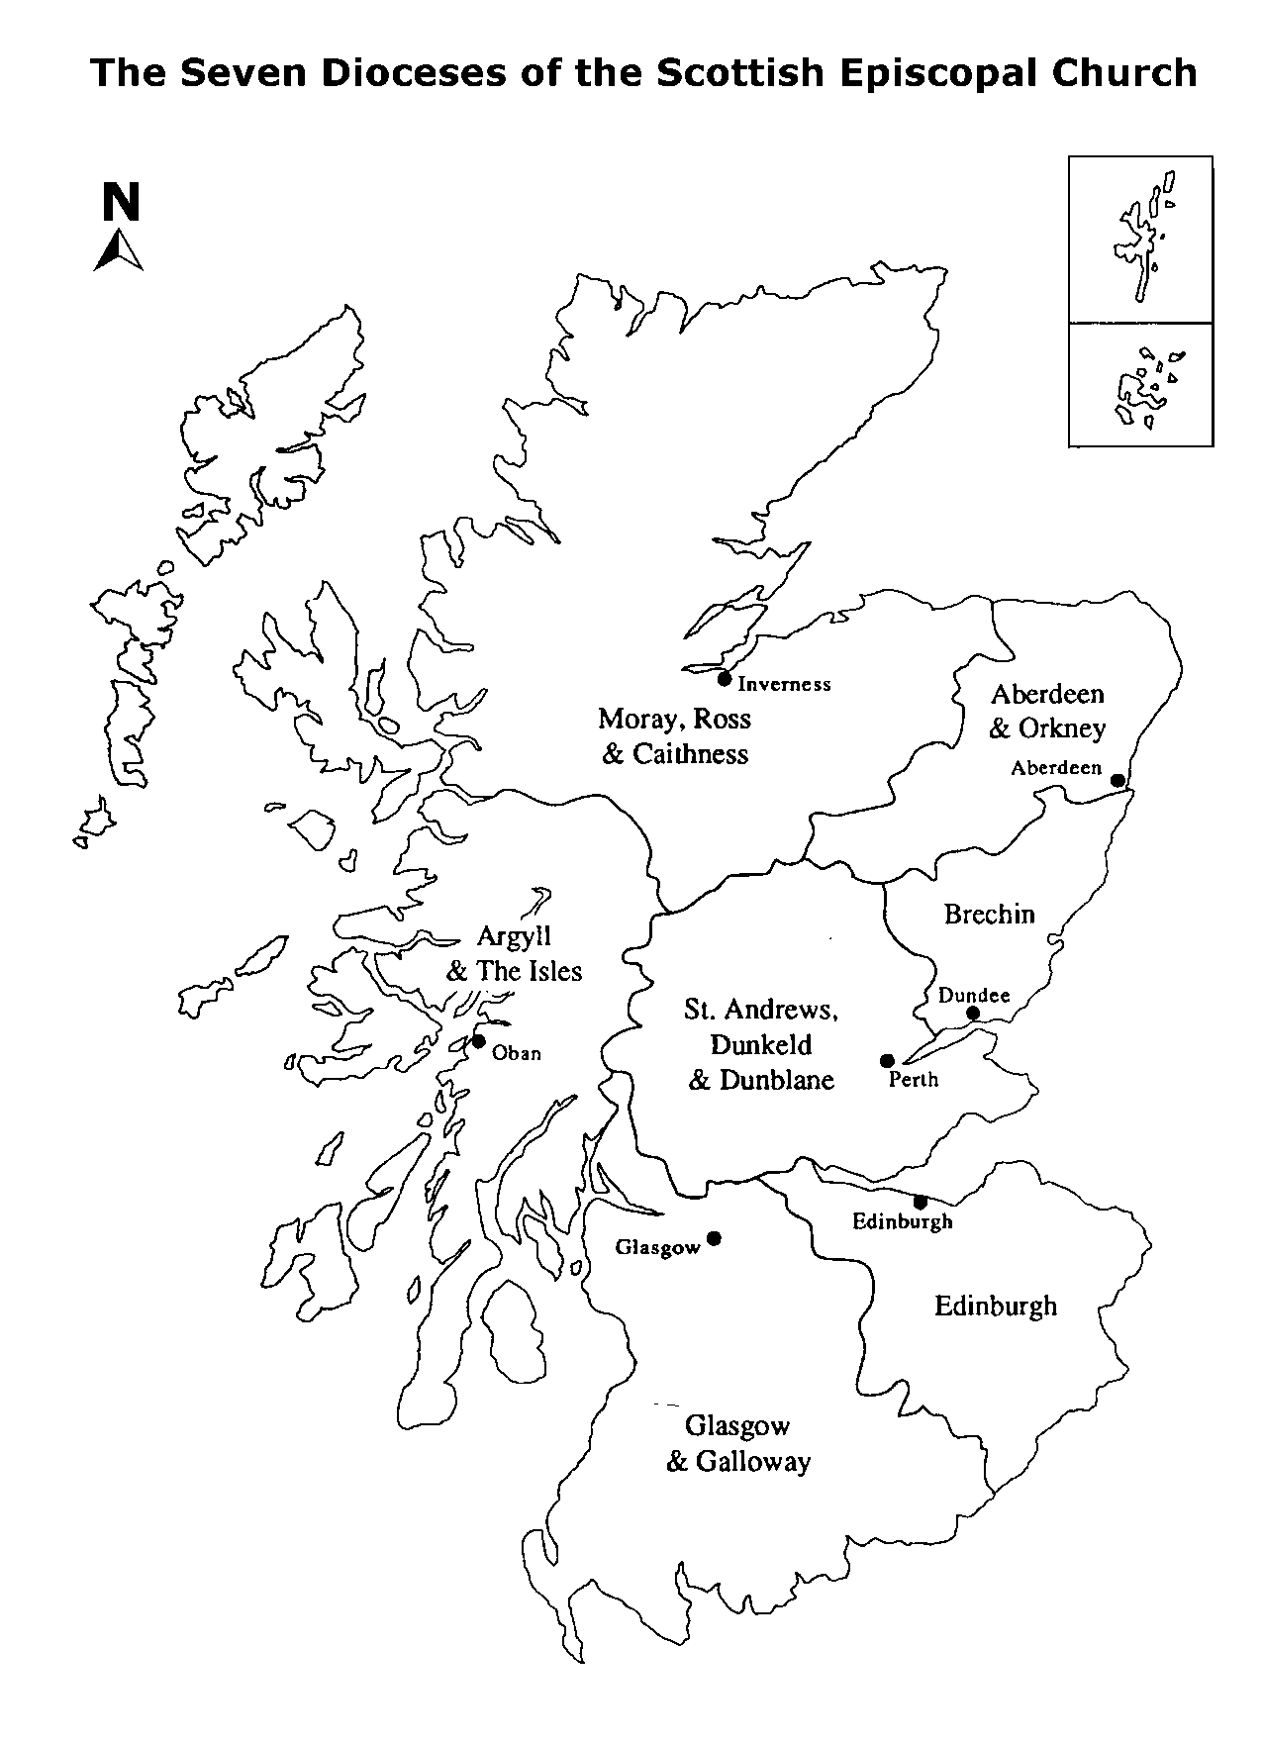

**22**

**18**

**14**

**32**

**12**

**12**

**14**

**12**

**Synod seats by Diocese**

**18**

**14**

**14**

**12**

**22**

**32**

## The General Synod Meeting

The Primus, or another member appointed by the Standing Committee, chairs the annual meeting. It comprises three houses: Bishops, Clergy and Laity.

The General Synod reaches decisions through a number of procedures. Most matters can be settled on a simple majority of Synod, voting as one house.

There is a separate, set procedure for matters that affect Canon Law.

* First, the motion must be passed by a simple majority of each of the three houses of the Synod;
* Second, it is referred to each diocese for consultation and comment;
* Third, it returns to Synod the following year when it needs to be passed by a two-thirds majority, with each house voting separately.

In theory, the Synod can break physically into its separate houses, although this is very unusual. When it does divide, the houses of Clergy and Laity are chaired by elected prolocutors.

**Voting**

Most voting is carried out by a show of hands. Coloured cards are issued to members to assist in the counting of votes.

**Procedure**

Clergy, Laity and Bishops all sit together throughout the sessions. The Chair sits facing them, alongside the Legal Assessor and the Secretary General. The Assessor advises the Chair on points of procedure.

Members who want to speak during a debate should raise their hand or stand up and wait to be called by the Chair. All remarks should be addressed to the Chair, with the usual preface: “*Primus (or Chair), Members of Synod*”.

Speakers should identify themselves and their diocese. Movers of motions are generally allowed to speak for 10 minutes, while other speakers are limited to five minutes.

No one other than the proposer of a motion is allowed to speak twice in the same debate. The proposer may respond to points made during the debate. The one exception to this is when a point of order is raised.

## How to get matters on the Synod Agenda

The formal agenda for the Synod is prepared by the Standing Committee.

Any member of Synod can propose a motion by notifying the Standing Committee by a set date before the Synod meeting. The deadline for these notifications is given in the papers sent out in March to convene the Synod. The Standing Committee then decides whether to include the proposed motion.

Members can also use Rule 10 of the Synod’s Rules of Order to propose a motion. Proposers need to give the Secretary General written notice of such a motion, normally before the start of the Synod meeting. The written notice should be signed by the motion’s mover and seconder and by 12 other members of Synod who are present at the meeting. Motions are presented in the form “That this Synod…” It is important that the motion sets out clearly what the proposer intends. Assistance in this is normally available. The mover is then allowed two minutes to address Synod on why it should consider the motion. If two thirds of those present vote in favour of hearing the motion, it can proceed to be debated.

Motions involving financial expenditure cannot be heard unless they are printed in the Synod agenda, alongside the observations of the Board or Committee within whose budget the expenditure would fall.

Proposers are encouraged to build support for their motions before bringing them to the General Synod. They can do this by bringing them to their diocesan synod or by discussing them with the Convener of the relevant Board or Committee.

Another way of getting the General Synod to consider a matter is to put a question to a board convener during the proceedings. This is a good way of raising an issue without the formality and precision of a specific motion. Where possible, questions should be written and submitted to the Secretary General in advance of Synod.

Anyone with further queries about General Synod procedure can always call one of the General Synod Office staff. All the contact details are inside the back cover of this guide. *The Rules of Order of the General Synod* in the General Synod Papers, contains more detailed guidance.

## The Rest of the Year

During the rest of the year, the General Synod’s work is carried out by its Boards, Committees, and by its officers who work in the General Synod Office.

The Standing Committee represents the General Synod in the day-to-day running of the Church. It draws up the agenda and sets the timetable for General Synod meetings. It is also responsible for the oversight of the General Synod Office.

Its members include a Lay Convener, elected by Synod, the Conveners of the Boards of the Church, the Primus, another Bishop, one further lay member elected by Synod’s House of Laity and two clerical members elected by Synod’s House of Clergy.

There are currently five Boards: Administration, Faith & Order, Information & Communication, Mission, and the Scottish Episcopal Institute Council.

The Boards’ key role is to interpret and carry out the broad policy guidelines laid out by the General Synod. Each oversees a specific area of the Church’s work.

Board Conveners are elected by the General Synod while members are appointed by dioceses to represent them.

The Boards are served by committees that form working groups, focused on specific areas. Members are chosen for their expertise in these specific areas – from information technology to overseas mission and youth work. They also keep in touch with any parallel committees operating in the Dioceses.

Every board and committee receives administrative and other support from the officers and staff of the General Synod Office and the Scottish Episcopal Institute.

The Church’s seven Bishops also meet regularly as the College of Bishops. This body is not a formal part of the General Synod structure.

## Boards and Committees

**The Administration Board**

The Administration Board is responsible for general administrative matters affecting the Church.

Its **Investment Committee** handles Church investments, mainly the Unit Trust Pool.

The Board’s **Retirement Housing Committee** oversees clergy retirement housing and related issues. Pension matters are the responsibility of the **Pension Fund Trustees**.

The **Buildings Committee** promotes good practice in relation to the care and maintenance of Church buildings. It also handles appeals under Canon 35.

The **Personnel Committee** addresses general, rather than specific, personnel issues relating to clergy.

**The Faith & Order Board**

The Faith & Order Board considers questions of Church government and organisation, as well as relations with the Anglican Communion and other Churches.

Its **Doctrine Committee** looks at the interpretation and expression of Church doctrine. It has three other committees, responsible **for Inter-Church Relations**, **Liturgy** and the Church’s laws or **Canons**.

**The Information & Communication Board**

The Information & Communication Board seeks to improve the flow of information and communication within the Church and between the Church and society.

**The Mission Board**

The Mission Board has responsibility for the strategic oversight of the Church’s mission In Scotland and abroad.

Its **Church in Society Committee** helps the Church in its engagement with the wider world. A sub-committee handles relations with other faiths.

The **Global Partnerships Committee** supports work overseas and promotes awareness of that work within Scotland.

The **Youth Committee** promotes work with young people in the Province including the running of the annual Glenalmond Camp.

**The Institute Council**

The fifth Board, known as the Institute Council, is the governing body of the Scottish Episcopal Institute and has strategic oversight of the delivery of formation and training for authorised ministry in the Church. It appoints a Management Committee with academic responsibility for programmes and curricula.

## Parking at General Synod 2019

General Synod 2019 is being held at St Paul’s and St George’s, Edinburgh. Please be aware that parking in the streets around the Church can be a challenge. This challenge is currently exacerbated because of works to the former St James Centre, near St Paul’s and St George’s. There is a car park nearby in the Omni complex. Please see the map below for more information:

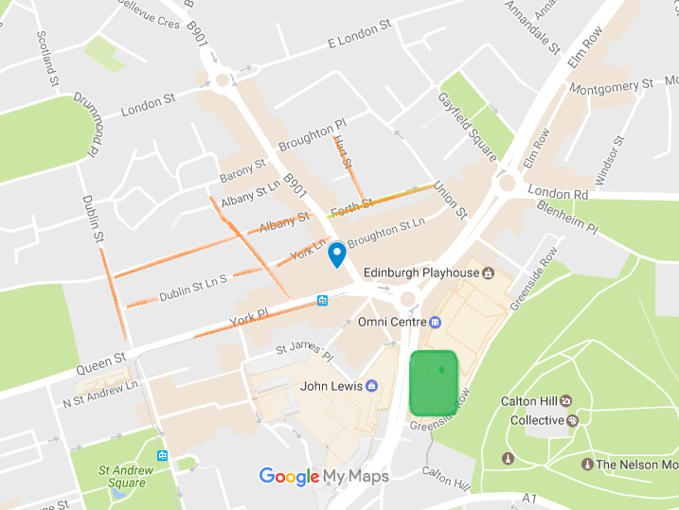



## General Synod & Scottish Episcopal Institute Officers

21 Grosvenor Crescent, Edinburgh EH12 5EE

Tel: 0131 225 6357 Fax: 0131 346 7247

Email: office@scotland.anglican.org

Website: www.scotland.anglican.org

**Secretary General:** Mr John F Stuart

Email: secgen@scotland.anglican.org

**Treasurer:** Mr Malcolm Bett

Email: treasurer@scotland.anglican.org

**Director of Communications:** Miss Lorna Finley

Email: press@scotland.anglican.org

**Church Relations Officer:** Miss Miriam Weibye  
Email: churchrelations@scotland.anglican.org

**Provincial Officer for the Protection of Children and Vulnerable Adults:**

Mr Donald Urquhart

Email: ChildProtection@scotland.anglican.org

**Pensions & Retirement Welfare Administrator, & Assistant Officer for the Protection of Children and Vulnerable Adults:** Dr Daphne Audsley  
Email: daphnea@scotland.anglican.org

**Principal of the Scottish Episcopal Institute:**

Rev Canon Dr Anne Tomlinson

Email: Principal@scotland.anglican.org

**Director of Studies of the Scottish Episcopal Institute:**

Rev Dr Michael Hull

Email: DoS@scotland.anglican.org

**Director Mixed Mode Training of the Scottish Episcopal Institute:**

Rev Richard Tiplady

Email: [DMM@scotland.anglican.org](mailto:DMM@scotland.anglican.org)

**Provincial Director of Ordinands:**

Rev Ian Barcroft (with effect from 1 June 2019)

Email: pdo@scotland.anglican.org