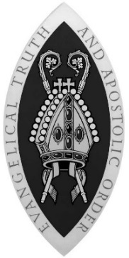
SCOTTISH EPISCOPAL CHURCH
PUBLICATIONS ORDER FORM

To order publications, email reception@scotland.anglican.org, phone 0131 225 6357, visit the General Synod Office reception, or post the form to General Synod Office,
21 Grosvenor Crescent, Edinburgh EH12 5EE.

You will be sent an invoice for the publications and any postage and packaging.

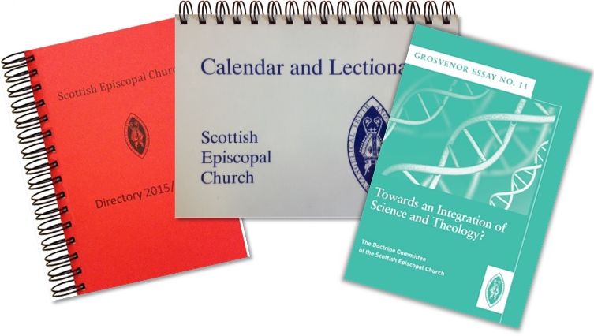

I understand that I will receive an invoice for the order which will include the cost of postage and packaging.
Signed Date
Deliver to: |  | Invoice to:
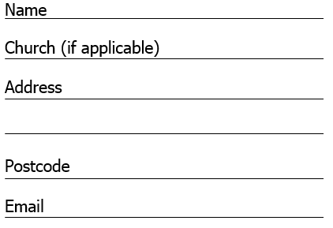 |  | Delivery Address
 |  | or:
 |  | Alternative Address:

Liturgy
Publication | Style | Price | Quantity | Total Cost
Scottish Liturgy 1982 | large print | £ 3.00
Scottish Liturgy 1982 with alternative Eucharistic Prayers | A5 size | £ 1.00
 | pew size | £ 1.00
Scottish Liturgy 1982 with Propers and Revised Common Lectionary | ring bound | £ 5.00
Scottish Liturgy 1970 | large print | £ 1.50
 | pew size | £ 1.00
Scottish Prayer Book 1929 | hard back | £19.50
Scottish Liturgy 1929 | large print | £ 3.50
Daily Prayer | ring bound | £ 9.00
Daily Prayer Short Form | pew size | £ 1.00
A Service of the Word 2015 | A5 size | £ 1.50
Holy Baptism 2006 | A5 size | £ 1.00
Affirmation of Holy Baptism | A5 size | £ 1.00
Marriage Liturgy 2007 | A5 size | £ 2.00
Funeral Rites 1987 | pew size | £ 1.25
Communion from the Reserved Sacrament 1997 | A5 size | £ 1.00
Scottish Ordinal 1984 | A5 size | £ 1.00

Braille Liturgies

Clergy Discount – Clergy receive 25% discount on all liturgy orders of 25 copies or more.
Scottish Liturgy 1929 | Braille | £ 3.00
Scottish Liturgy 1970 | Braille | £ 3.00
Scottish Liturgy 1982 | Braille | £ 1.00
Publications
Publication | Price | Quantity | Total Cost
Church Directory 2020/2021 (Red Book) | £ 9.00
Annual Report for year ended 31 December 2018 | £ 5.00
Calendar and Lectionary (updated 2015) | £ 6.00
Guide to the Calendar and Lectionary | Free
Guide to getting married in Church | Free

Grosvenor Essays
Number | Subject | Price | Quantity | Total Cost
1 | Sketches Towards a Theology of Science | Unavailable
2 | Theology and Power of the Image | £ 3.00
3 | The inter-faith encounter | Unavailable
4 | The Shape of our Church: an essay in Descriptive Ecclesiology | £ 2.50
5 | On Salvation | £ 2.50
6 | Thinking the Nicene Creed: Death and Resurrection – New life of Christ | £ 3.00
7 | Thinking the Nicene Creed: Incarnation | £ 3.00
8 | Marriage and Human Intimacy | £ 3.00
9 | The Art of Dying Well | £ 5.00
10 | The Church and Scottish Identity | £ 5.00
11 | Towards an Integration of Science and Theology? | £ 6.00
12 | Prayer and Spirituality | £ 6.00

Promotional Materials
Publication | Price | Quantity | Total Cost
Church Signs English  Single signed 29½“ x 14½” | £ 55.00
Church Signs Gaelic  Single signed 29½“ x 14½” | £ 55.00

Publication | Price | Quantity | Total Cost
Pastoral Offices - Priests | £ 5.75
Pastoral Offices – Deacons | £ 5.75
Pastoral offices – Lay Readers | £ 5.75

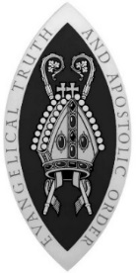

General Synod of the Scottish Episcopal Church
Scottish Charity No SC015962

