Scottish Episcopal Church
[Congregation name]
Risk Register
Updated December 2019

INDEX
- Governance Risks (Pages 3-4)
  - Strategic planning
  - Vestry members role
  - OSCR and SEC constitutional guidelines
  - Conflict of interest
- Operational Risks (Pages 5-8)
  - Safeguarding procedures
  - Data Protection breach
  - Loss of key staff or volunteers
  - Employment contracts
  - Stationary and documentation compliance
  - Remuneration of vestry members
  - Maintenance of church
  - Insurance policies
  - Health and safety
  - External trips
- Financial Risks (Pages 9-11)
  - Financial wellbeing
  - Compliance with accounting rules
  - Acting outside of powers
  - Application of resources
  - Security of payments
- External Risks (Page 12)
  - Loss of reputation
EXPLANATORY MEMORANDUM
The risk register contained within the following the pages is a practical way of identifying and mitigating risks that are posed to the congregations of the SEC. Risk cannot be eliminated completely, but it can be dealt with effectively through the correct procedures.
When completing the risk register the vestry members may wish to refer to a number of publications that they might find useful. Using the publications for regulatory guidance and the register contained as a framework will allow for a thorough review of the risks facing a congregation. The publications include:
- SEC’s Guidance for Vestries on the Charities and Trustee Investment (Scotland) Act 2005 - http://www.scotland.anglican.org/vestry-resources/vestry-responsibilities/charities-and-trustee-investment-scotland-act-2005-guidance-for-vestries/
- Charity Commission for England and Wales Guidance – ‘Charities and risk management (CC26)’ (Still useful for guidance throughout the UK although not applicable in Scotland) - https://www.gov.uk/government/publications/charities-and-risk-management-cc26
- Shepherd and Wedderburn’s SEC Risk Management Note
- SEC Model Constitution 2008
- OSCR Charities Statement of Recommended Practice (SORP) applicable to charities preparing their accounts in accordance with the Financial Reporting Standard applicable in the UK and Ireland (FRS 102) to be read with Update bulletin 1 - http://www.charitysorp.org/media/642756/frs102-bulletin-1.pdf
What is risk?
Risk can be defined as the level of exposure to uncertainties that a congregation must understand and effectively manage. Risk is different to the term ‘issue’ which is defined as an unplanned event that has already happened and needs action to manage. The important terminology applicable to risk is of ‘exposure’ and ‘uncertainty’ – both are required for there to be a risk posed. It is also important to note that some risks are of an ongoing nature. A broad classification system has been used in the register to provide for four classes of risk:
- Governance
- Operational
- Financial
- External
The risks contained are not an exhaustive list and congregations should seek to add any further risks they feel require attention. At the end of each class or risk there is a blank section to allow for any additions and can be extended as required.
Assessing Risk
A formula can be used to assess the overall risk level by combining the score afforded to the likelihood of an event and the severity of the impact. With the likelihood being (‘x’) and the impact being (‘y’) the formula of ‘xy+y’ can be used to gain a measure of the risk – the ‘+y’ at the end of the formula allows for a greater weighting to be given to the impact of an event. This provides for a range of scores from 2-30 and enables a risk to be placed within one of four categories highlighted on the risk colour map on the following page, along with tables for likelihood and impact definitions.

Impact Score
Insignificant | 1 | No impact on service  No impact on reputation  Litigation risk remote  Complaint unlikely
Minor | 2 | Slight impact on service  Slight impact on reputation  Litigation risk possible  Complaint possible
Moderate | 3 | Some service disruption  Potential for adverse publicity  Litigation risk probable  Complaint probable
Major | 4 | Service disrupted  Adverse publicity unavoidable  Litigation risk expected  Complaint expected
Extreme/Catastrophic | 5 | Service interrupted for significant time  Major adverse publicity unavoidable  Major litigation risk expected  Resignation of senior management and board  Loss of beneficiary confidence
Likelihood Score
Remote | 1 | May only occur in exceptional circumstances
Unlikely | 2 | Expected to occur in a few circumstances
Possible | 3 | Expected to occur in some circumstances
Probable | 4 | Expected to occur in many circumstances
Highly probable | 5 | Expected to occur frequently in most circumstances
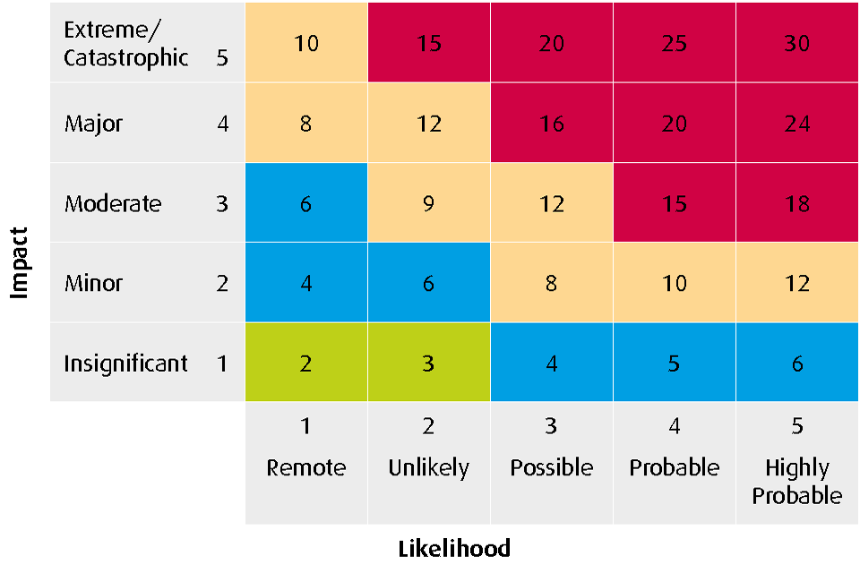

SCOTTISH EPISCOPAL CHURCH CONGREGATION RISK REGISTER

 | Risk | Risk | Likeli-hood | Impact | Total | Mitigating procedure /  monitoring process | Net Risk [Low/ Med/High] | Responsibility | Further Action Suggested/ Further Comments
1.1 | Governance | Lack of strategic planning |  |  |  | Regular meetings to consider:  - Future of the congregation  - Opportunities for mission  - Service in the community  - Growth of the congregation  - Any other congregational specific issues |  | [Vestry Members]
1.2 | Governance | Failure of Vestry members to understand their role; vestry lacking appropriate skill set. |  |  |  | Checks regarding eligibility should be made, alongside consideration of skillset. Each new vestry member should sign a declaration of eligibility confirming that they are not disqualified from acting. They should confirm that they meet the HMRC “Fit and Proper Person Test”. These declarations should then be held for vestry records. There is a style of eligibility declaration and guidance available on the SEC website.  Vestry members should receive an induction, including a discussion of their role and a briefing on any other relevant information considered necessary e.g. history of the congregation.  Vestry should regularly consider succession planning in its membership to endeavour to ensure appropriate skills set. |  | [Vestry Members] | A person may be disqualified if they have been convicted of an offence involving dishonesty or bankruptcy along with other qualifying circumstances found at Section 69 and 70 of the Charities Act 2005.  Any member of the vestry that comes under the disqualified category after joining must resign immediately.  Vestry Members should regularly refresh their understanding of their responsibilities in light of changes to the regulatory environment, including any new or update guidance issued by OSCR.
1.3 | Governance | Failure to adhere to the OSCR guidelines or SEC Code of Canons or congregational constitution. |  |  |  | Prior consent must be obtained from the OSCR before any changes can be made to the constitution.  The SEC Model Constitution should be the standard format used and any vestries wishing to depart from it should consult the Registrar of the Diocese with an explanation of why it is not appropriate. |  | [Vestry Secretary]
1.4 | Governance | Conflict of interest arising for a vestry member. |  |  |  | Conflicts should be handled and communicated openly.  Conflicts should be declared and noted for vestry records. |  | [Vestry Members] | The member must put the interests of the congregation before those of another person. Any conflict must be disclosed, and the conflicted party may be required to refrain from participating in any deliberation or decision of the vestry members with respect to the matter in question.

 | Risk | Risk | Likeli-hood | Impact | Total | Mitigating procedure /  monitoring process | Net Risk [Low/ Med/High] | Responsibility | Further Action Suggested/ Further Comments
2.1 | Operational | Risk of harm to children and vulnerable people in the congregation arising from failure to implement proper safeguarding procedures.  Failure to comply with legislation in relation to criminal record checks and in relation to associated safeguarding procedures and regulatory compliance. |  |  |  | The Vestry should ensure that safeguarding is a regular feature on its agenda and receive regular reports that appropriate procedures are in place and adhered to.  The following are vestry responsibilities, but the administration may be delegated to the PVG Co-Ordinator:  - Apply SEC Safe Recruitment Policy to all employees and volunteers.  - Apply for Protecting Vulnerable Groups (PVG) Scheme record disclosures for all employees and volunteers appointed to do Regulated Work with children and/or protected adults.  - Maintain records of employees and volunteers in accordance with data protection rules.  The following are Vestry responsibilities:-  - Ensure that employees and volunteers working with children and/or protected adults receive training for their role and ongoing supervision.  - Appoint a regulated Work Employer and maintain a Regulated Workforce Register.  - Report any safeguarding concerns and allegations to the Provincial Safeguarding Officer and, of appropriate, statutory agencies. |  | [Vestry Members]
2.2 | Operational | IT failure, damage or theft. |  |  |  | Adequate arrangements for maintenance, repair or replacement of key equipment. Regular back up media held on different site. Insurance to provide cover in respect of reinstatement of data and increased costs of working arising out of damage to computer equipment. |  | [Vestry Secretary]
2.3 | Operational | Loss of clergy key staff or volunteers. |  |  |  | Appropriate succession planning for key positions (such as rector/ vestry secretary, treasurer/ PVG co-ordinator) held with the congregation.  Consider notice periods and handovers with key members of the vestry.  Review and agree upon a recruitment process. |  | [Vestry Members] | Appropriate contingency planning should be made for the event of unforeseen events which would hamper operations, for example access to bank accounts. Such events might include unexpected death or incapacity of key personnel.
2.4 | Operational | Failure to comply with relevant employment regulations or pensions legislation. |  |  |  | Seek advice from Diocese, the Registrar or other external source of advice.  Consider guidance on auto-enrolment available on the provincial website. |  | [Vestry Members] | Congregations will often only have only one or two actual employees, but it is important to ensure that any employment contracts are dealt with properly.
2.5 | Operational | Failure of documentation and stationary issued by the congregation to contain the prescribed information showing that the congregation is a charity – Charities References in Documents (Scotland) Regulations 2007. |  |  |  | Both internal and external documentation etc should fulfil the requirements under the Regulations.  The prescribed information can be found at Section 10 in the SEC Guidance on the Charities and Trustees Investment (Scotland) Act 2005. |  | [Vestry Secretary]
2.6 | Operational | Failure to comply with requirements for trustee remuneration provided for in Section 67 of the Charities and Trustee Investment (Scotland) Act 2005. |  |  |  | Remuneration of services is allowed for vestry members in adherence with the conditions in Section 67. These can be found at Section 3 in the SEC Guidance on the Charities and Trustees Investment (Scotland) Act 2005.  If any vestry member or any close relative of a vestry member is being paid whether directly or indirectly for providing services for the congregation then a written remuneration agreement should be entered into. |  | [Vestry Members]
2.7 | Operational | Failure to maintain church building fabric. |  |  |  | Quinquennial property surveys of the condition of the church buildings including rectory should be carried out regularly and items identified timeously addressed |  | [Vestry Members] | Consultation with the congregation should be carried out before any maintenance work to make them aware of any possible disruption.
2.8 | Operational | Failure to maintain appropriate and adequate insurance. |  |  |  | Duty of maintenance and insurance lies with congregations.  Up to date insurance policies should be in place on:  - public liability  - buildings & contents  - any other relevant cover including trustee indemnity for vestry members. |  | [Vestry Secretary] | As far as possible, mitigate for risks including catastrophic events like a fire or flood.
2.9 | Operational | Failure to address issues of health and safety. |  |  |  | Property Convener to ensure that Health and Safety regulations are complied with (including regular risk assessments) including in relation to the operation of fire safety equipment; use of fire exits; testing of portable electrical devices. |  | [Vestry Secretary] | Issues that arise with health and safety may include (1) fire safety; (2) electrical appliances and systems; and (3) internal safety of building for all visitors with particular emphasis on movement of frail and elderly.
2.10 | Operational | Incidents on external trips with the church – i.e. youth camp. |  |  |  | Individual risk assessments should be undertaken for each trip and permission is sought from parents for children under the age of 18.  If not already in place, a reporting process should be created for any concerns to be raised.  Insurance should be obtained, where applicable, for any trips outside of the church. |  | [Vestry Members / Congregation]
2.11 | Operational | Relationship breakdown between key individuals. |  |  |  | Careful and ongoing communication of expectations and job specifications on all appointments.
 | Operational | [ADDITIONAL RISK] |  |  |  | [MITIGATING PROCEDURES]

 | Risk | Risk | Likeli-hood | Impact | Total | Mitigating procedure /  monitoring process | Net Risk [Low/ Med/High] | Responsibility | Further Action Suggested/ Further Comments
3.1 | Financial | Failure to ensure financial wellbeing. |  |  |  | Ongoing monitoring of congregation’s finances including:-  - Production of regular financial statements for Vestry scrutiny.  - Annual accounts audited/ examined by outside financial assessor.  - Production of regular budgets  - Review of sources of income and consideration of diversification (eg over-dependency of a small number of key donors, hall lettings, investment income).  - Ensure that there are always adequate reserves available as part of every congregation’s ongoing accounting processes.  - Taking of appropriate advice in relation to investments |  | Vestry Treasurer | The Vestry must ensure it is always aware of the financial health of the congregation.  The Vestry Treasurer must be fully aware of the responsibilities of the role and provided with support where necessary (information about the Treasurer’s role is available from the Provincial Website)
3.2 | Financial | Failure to comply with OSCR requirements and accounting rules. |  |  |  | Ensure submission of the Annual Accounts and Return to the OSCR by specified date – OSCR will send reminders.  Required scrutiny of appropriately qualified external examiner/ auditor.  Treasurer to be aware of applicable accounting rules. |  | [Vestry Secretary/ Treasurer]
3.3 | Financial | Risk of Vestry members acting outside of powers or entering into onerous contracts (eg long-term contracts with penalties for early termination). |  |  |  | Any vestry member committing to enter into an obligation with a third party should do so after vestry agreement/ authorisation. |  | [Vestry Members] | Members should satisfy themselves that sufficient funds are available or assured and ensure that any obligation is being entered into within the powers of the congregation and with their best interests in mind.  All vestry members should be aware of relevant financial policies and procedures.
3.4 | Financial | Failure by vestry members to apply resources appropriately. |  |  |  | At all times Vestry Members must ensure that they are spending the congregations' resources properly and being prudent and careful with the congregation’s assets.  Vestry members may wish to maintain a register of assets and ensure they are kept securely. |  | [Vestry Secretary / Vestry Members] | Duties imposed on vestry members when dealing with investing funds include:  - To act prudently  - To act with reasonable skill, care and diligence  - To exercise independent judgement  - To safeguard the congregation’s assets
3.5 | Financial | Failure to ensure adequacy of security of payments. |  |  |  | Internet banking can pose a larger risk due to the ease of access. Any larger amounts of money being distributed should require two signatures or approval of two separate parties. |  | [Vestry Secretary / Vestry Members] | The limit on what constitutes a larger amount should be decided by the Vestry – anything in excess of £500 would seem prudent.  Additional authorisation for exceptional large amounts may also be a worthwhile additional check.
 | Financial | [ADDITIONAL RISK] |  |  |  | [MITIGATING PROCEDURES]

 | Risk | Risk | Likeli-hood | Impact | Total | Mitigating procedure /  monitoring process | Net Risk [Low/ Med/High] | Responsibility | Further Action Suggested/ Further Comments
4.1 | External | Loss of reputation arising from inappropriate use of social media or other public actions on behalf of congregations. |  |  |  | Consider who controls any social media or has interaction with the public on behalf of the congregation.  Awareness of the benefits/dangers that social media can have.  Consider a response plan for dealing with any media/online attention.  Guidance on GDPR is available on the SEC website.  Consider reputational issues if any arising from suitability of external bodies using church hall premises.
 | External | [ADDITONAL RISK] |  |  |  | [Mitigating Procedures]

