SAINT NINIAN’S SCOTTISH EPISCOPAL CHURCH GLEN URQUHART

PROFILE

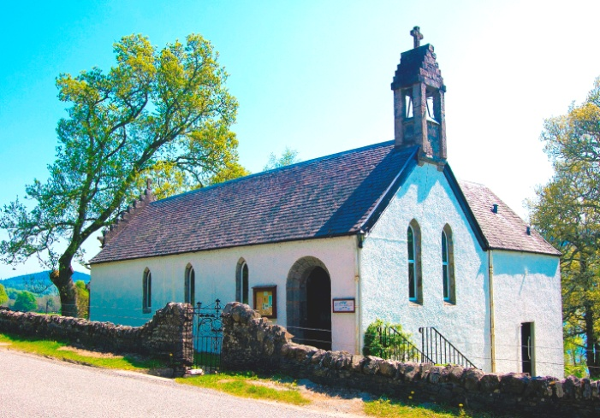

Location

St. Ninian’s is in the diocese of Moray, Ross and Caithness, which is centred on St. Andrew’s Cathedral in Inverness. The church is situated in Glen Urquhart in a rural location, on the north shore of Loch Meiklie, on the A831, about five miles west of Drumnadrochit and seven miles east of Cannich. The parish covers a wide area, reaching about 30 miles from just south of Fort Augustus in the Great Glen to Beauly in the north, and about 25 miles from Drumnadrochit in the east, westwards up the glens of Strathglass.

The church

The church is a small white-harled stone building, in a lovely location beside Loch Meiklie. It is equipped inside with pews to seat about 40. It was built in 1853 and is now a listed building; the architect was Dr. Alexander Ross. It has crow-stepped gables and a bell-tower at the west end. From the rear of the church a stair leads up to the vestry, which has an oriel window overlooking the loch, and an adjacent toilet. The east end of the church has three stained glass windows, while the north and south sides have plain lancet windows. Below the church is a cellar used for storage, a meeting room, used mainly for coffee after services, and a disabled toilet.

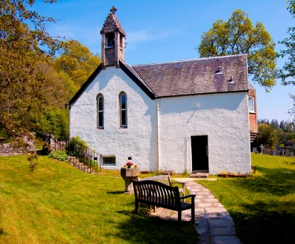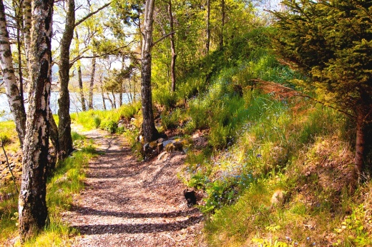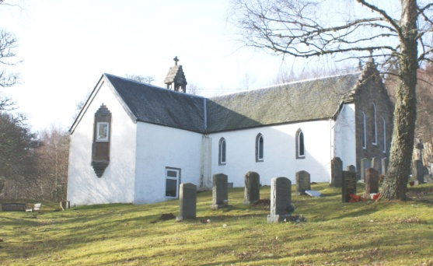

An Early Christian cross slab is set into the front of the altar; it has been associated with St. Ninian, who may have been one of several Early Christian missionaries to reach Glen Urquhart. Other notable features are a roof beam with a Gaelic inscription, and rugs with Celtic animal motifs in the Sanctuary, designed by George Bain.

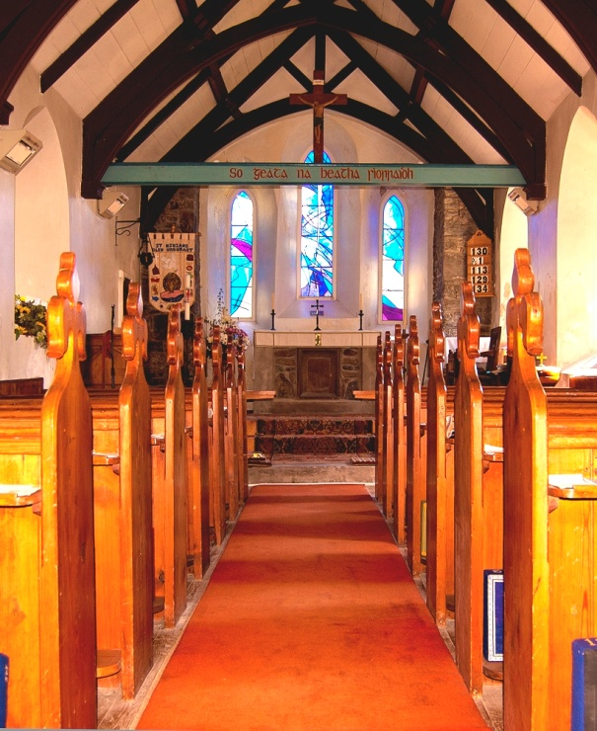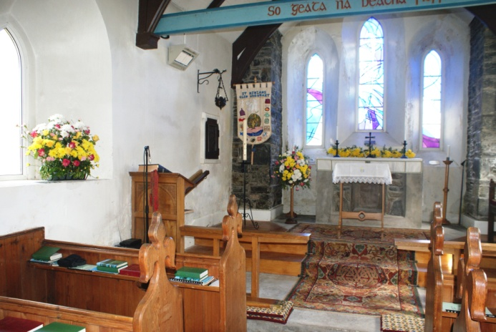

Recently the church had begun to suffer badly from damp. Thanks to a successful application to the Heritage Lottery Fund, we have been able to remedy this by replacing the harling and at the same time we have carried out various other renovations. Most notably a disabled toilet was added to the downstairs coffee room, and we are about to install a more efficient heating system in the church itself.

The church has extensive and very attractive grounds, with paths leading down towards the loch. To the east of the church is the burial ground, with a small area for cremated ashes. To the west is a car park.

The church does not have a hall as such, but the local community hall at Balnain, about a mile away, is available for us to hire for any event for which a hall is required.

Services

Normally we have Sung Eucharist at 11am on Sundays, with Holy Communion at 11am on Thursdays. Music for the Sunday service is provided by a digital organ. (There is an actual organ, but at the moment we have no organist). Additional services are held as appropriate, e.g. in Holy Week and at Christmas.

The congregation

The church has at present 20 to 30 members, with a few more, not actually members, who come fairly regularly to services. Our Thursday services in particular often have an ecumenical feel, with several of those attending being actually members of the Church of Scotland. Average attendance on “ordinary” Sundays is about 16, with many more at festivals of the Church or other special services. We do our best to give any visitors a cordial welcome. On Sundays we have coffee after the service, which provides members with an opportunity to catch up and enables us to extend our welcome to visitors or newcomers with a friendly chat.

There are not many young families in the congregation, and recent efforts to attract more young people have had limited success. Many people leave the area in search of work, but some return when they retire. The area is also popular with people, often from England, wishing to relocate to the Highlands of Scotland for their retirement years, and with those who have bought property here to use as second homes. For people who have been members of the Anglican Church elsewhere, our Scottish Episcopal Church offers them a spiritual home.

There are a number of people living in the area who do not attend any church regularly but who have a loose attachment to St. Ninian’s, coming to our services on special occasions, e.g. Easter Sunday, the Christmas carol service etc. We also welcome a fair number of visitors, particularly during the summer months, as our church is situated in a very popular tourist area.

Involvement of laity

There is a lay ministry team licensed by the Bishop; they assist the priest at services, and also on occasion take services with the reserved sacrament, and they take communion to the sick or housebound. We feel that the laity could potentially play a greater part in the life of the Church, and would like to explore this option.
Members of the congregation are also involved on a voluntary basis in many aspects of the running of the Church. Several serve on the Vestry, which meets regularly to conduct all our affairs. Two present members and one former member have worked extensively on all aspects of the bid for Heritage Lottery funding for our building renovations and on supervising the actual work. Church members also serve on a rota for cleaning the church, arranging flowers, making coffee after services etc.

Activities, outreach

Despite its small numbers, the congregation is very active and organizes events which serve partly as fundraising and partly as outreach to the community. Our main fundraising event is the Raspberry Tea in September (a tea with scones and raspberry jam, plus stalls and a raffle), but there are also quiz evenings, talks and participation in other community events as the opportunity arises.

The priest can share with clergy of other denominations in visiting the local schools, and there is a monthly service in the Care Centre in Drumnadrochit, which provides day care to elderly people from the community. For a time a monthly service was conducted in Fort Augustus, but this received little support. The church enjoys a cordial relationship with churches of other denominations in the area.

The Church has a website - www.stniniansglenurquhart.org.uk - and also a Facebook page (Saint Ninians Glen Urquhart). These serve to let people know of services and events, to inform people about the Church and to make our presence known to as wide a public as possible. The website receives an average of about 20 visits per week. Our Facebook page has 38 followers and our posts on it are seen by an average of about 60 people.

Charities

The Church supports three charities by means of special collections at various times of the year. These are Mission Aviation Fellowship, Send a Cow and The Friends of the Spafford Children’s Center [sic] in Jerusalem. Donations of food for the local Food Bank are taken on occasions e.g.at the Harvest Thanksgiving. We also respond with special collections to particular disasters or circumstances e.g. refugees.

Finances

The Church receives a steady income from its members’ offerings, supplemented by the Gift Aid scheme. Donations are received from time to time from individuals, and we have a significant amount of savings in a deposit account. We have faced major expenditure with the present building renovation work, which we could not have undertaken without a grant from the Heritage Lottery Fund. A proportion of the costs have to be borne by the Church, but we do not envisage any problem in meeting these obligations.
The Church is a registered charity (SCO 14759).

Accommodation for priest

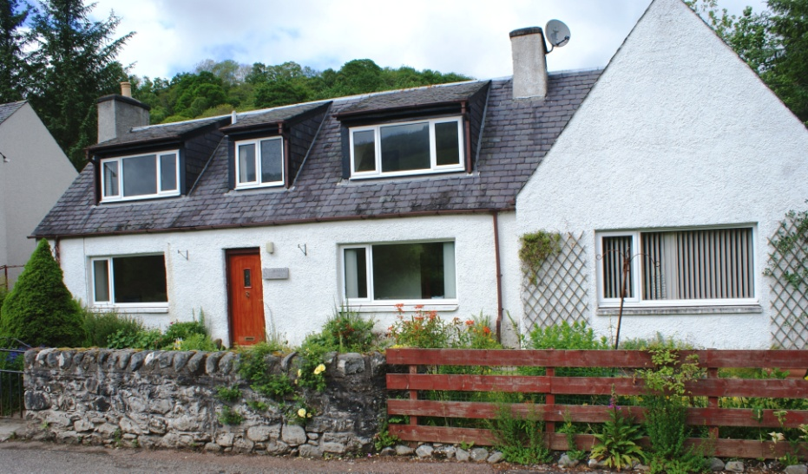

There is a house for the resident priest: St. Ninian’s Cottage is situated in the village of Milton, just off the A831, about a mile west of the larger village of Drumnadrochit and about four miles east of the church. Details of the property are as follows:

Ground floor: hallway, 2 reception rooms, fitted kitchen, utility room, toilet / shower-room.
First floor: two bedrooms, bathroom, airing cupboard.
Oil-fired central heating.
Well-maintained gardens to front and rear.
Gravel drive at side of house leading to stone outbuildings at rear.

Drumnadrochit, on Loch Ness and close to Urquhart Castle, is a busy tourist destination. It has a Post Office, convenience stores, gift shops, a doctors’ surgery, a chemist’s, a primary school and a secondary school. It is on the A82 and has regular bus services to the city of Inverness (14 miles) and westwards down the Great Glen to Fort Augustus and Fort William. Some buses to and from Cannich go through Milton.

Glen Urquhart is an area of great natural beauty, with the River Enrick, Loch Meiklie and a backdrop of mountains. Forestry plantations offer extensive forest walks. To the west the glens of Strathglass include Glen Affric, a National Nature Reserve with spectacular mountain scenery including several Munros.

Proposed agreement with resident priest

The position offered is on a House for Duty basis, on the following terms:
Non-stipendiary, non-pensionable.
Part-time: Sundays plus two days a week.
Holiday entitlement: six weeks per year including Sundays.
Length of tenure: five years in the first instance, but may be extended with approval from the Bishop.
Accommodation: free use of St. Ninian’s Cottage. The Church pays Council Tax, buildings insurance, maintenance and repairs, electricity, heating oil, telephone rental, business calls and Broadband.
The priest is entitled to fees for officiating at weddings, funerals etc. (but not fees for the use of the church).
The Church bears the expenses of engaging visiting clergy during the resident priest’s absence on holiday or if off sick.

Mission statement

“Where God is known, faith is grown and love is shown”.

We look forward to working with our new priest to explore new ways in which we can work towards fulfilling the aims of our mission.

.

